**PRACTICAL 3A**

**AIM:** Run and analyze the output of following commands in Linux – ifconfig, ping, netstat, traceroute.

**1) ifconfig** (For Windows it is ipconfig):

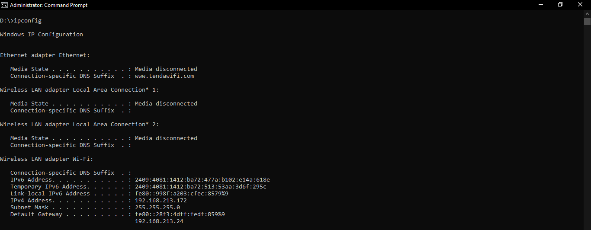

**2) ping:**

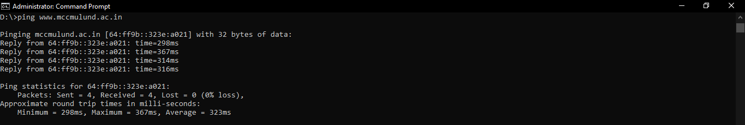

**3) netstat:**

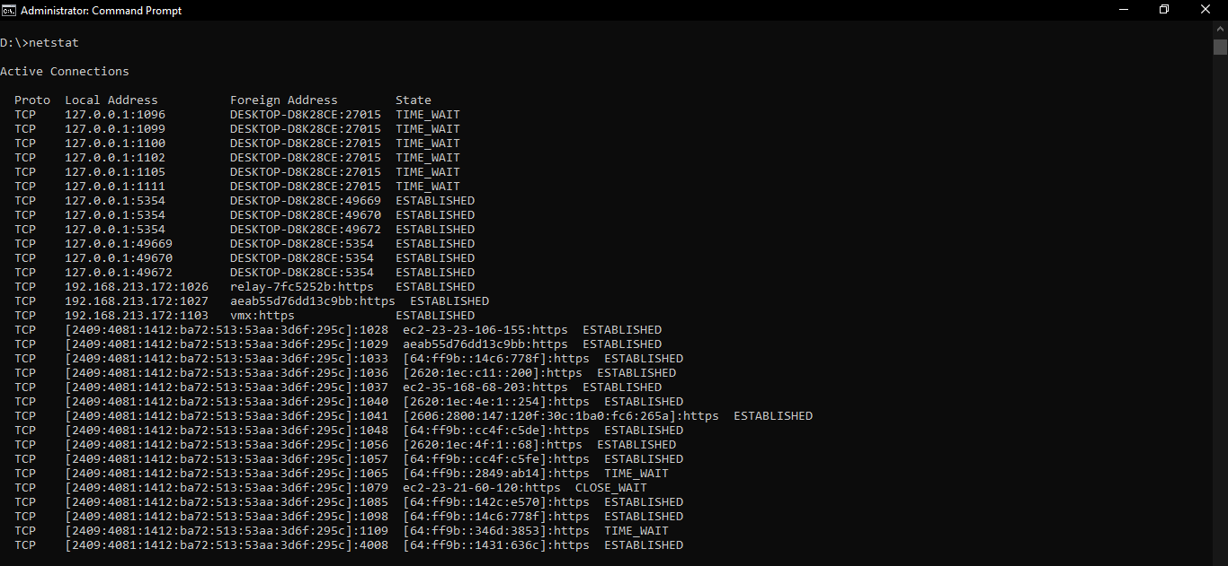

**4) traceroute:**

